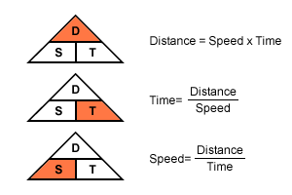Name:______________________

**DISTANCE, TIME, SPEED PRACTICE PROBLEMS**

***YOU MUST SHOW YOUR WORK.***

**SPEED**

1. If a car travels 400m in 20 seconds how fast is it going?
2. If you move 50 meters in 10 seconds, what is your speed?
3. You arrive in my class 45 seconds after leaving math which is 90 meters away. How fast did you travel?
4. A plane travels 360,000 meters in 900 seconds. What was its speed?
5. It takes Serina 0.25 hours to drive to school. Her route is 16 km long. What is Serina’s average speed on her drive to school?

**TIME**

1. How much time will it take for a bug to travel 5 meters across the floor if it is traveling at 1 m/s?
2. You need to get to class, 200 meters away, and you can only walk in the hallways at about 1.5 m/s. (if you run any faster, you’ll be caught for running). How much time will it take to get to your class?
3. In a competition, an athlete threw a flying disk 143 meters through the air. While in flight, the disk traveled at an average speed of 13.0 m/s. How long did the disk remain in the air?

**DISTANCE**

1. How far can you get away from your little brother with the squirt gun filled with paint if you can travel at 3 m/s and you have 15s before he sees you?
2. How far can your little brother get before his gun runs out of paint if he can travel at 2.5 m/s and if fired continuously the gun will run out of paint in 16 seconds?
3. If you shout into the Grand Canyon, your voice travels at the speed of sound (340 m/s) to the bottom of the canyon. How deep is the Grand Canyon at a spot where someone at the bottom can hear your voice 3.5 seconds after you shout?